Hey folks! I'm Vee (they/them), and I'm officially a First-Year Student of Texts and Technology, although I also took some coursework in the program last year before applying. I'm also a Visiting Instructor in the Department of Rhetoric & Writing. My research interests are currently experiencing Early-PhD Pinball Syndrome, but here's the basic gist - I came in as someone quite interested in Disability Studies and autistic identity as well as queer and trans rhetorics. These things are all still very near and dear to my heart, but after crossing paths with Dr. Salter last year, I'm now also considering embracing my background in Japanese Studies to marry my interests of rhetoric and Japanese Culture to examine rhetoric in Japanese video games. I'm also particularly interested in online teaching development for faculty. I was a bit of an 'early adopter' for online coursework as an undergrad as a form of accommodation for myself. Every opportunity I had to take an online class in undergrad, I took it, because it gave me greater flexibility to be a hybrid student, but this also meant that many of my early college experiences were a bit lackluster because back then in what would've been the early 2010s, it was exceedingly common that fully asynchronous courses delivered through an LMS (like this one!) involved little to no human interaction, standardized multiple choice assessments, and a great deal of rote memorization of an assigned text. When we were all thrust online a few years back due to the pandemic, it became the case that everyone became a sort of emergency online teacher, and I've noticed (and worried) in the 'post'-pandemic era that we'll see a return to some of those lackluster online course development methods. So, one thing that's particularly important to me from the perspective of accessibility is helping faculty to develop fully asynchronous and mixed-mode writing courses that are equally or more engaging than fully F2F courses.
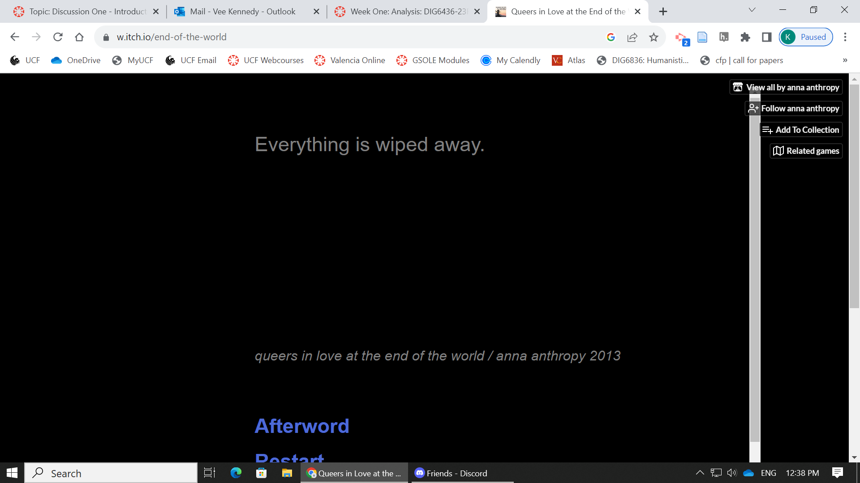
Now, as for my example of electronic literature, this is a bit of a cheat because this one comes from our syllabus from this course and we'll engage with it a bit later on at the end of this semester -- Queers in Love at the End of the Universe by Anna Antrophy
Links to an external site.
. This text stuck out to me when I was reading through the syllabus given my research interests and I clicked it when I was in the middle of doing a thousand other things and somehow spent an hour or so toying around with it. The basic premise is that you, a queer femme, are moments from the end of the world with another queer femme person, and regardless of what options you choose or how you opt to spend those last ten seconds at the end of the world, you have a clock counting down and you're both about to die. It's simple but also somehow poetic and beautiful, and game-ified. It is perhaps less so than Porpentine's With Those We Love Alive from this week's examples, in that it also has a much more limited scope. I found myself experiencing a whole slew of emotions with it, trying to put in various permutations to attempt to somehow get a different ending for my character and her lover. As an itch.io piece, it is certainly game-ish in nature, but it's entirely text based with no graphics, so it feels to me quite literary in nature. It meshes with the definitions we see in the introduction lecture perfectly in this case. Hayles mentions an example of Joyce's afternoon, a garden story, which while I am not familiar with yet, she describes as an example of hypertext fiction due to its characterization by linking structures (Hayles 6). Later on Hayles also states in the reading for this week: "The demarcation between electronic literature and computer games is far from clear; many games have narrative components, while many works of electronic literature have game elements," (Hayles 8). I've attached a screencastify of an example run as well.
In terms of the definitions we've come across this week for how to define electronic literature, in addition to putting it in the contexts that Hayles does above, I'd also like to think about the piece in terms of the two definitions that are embraced in the diRosario, Meza, and Grimaldi reading, which apparently come from the ELO's definition of Electronic Literature and one of Scott Rettberg's. First, ELO's definition as quoted in the diRosario, Meza and Grimaldi reading refers to works with literary aspects that make use of capabilities provided by a computer (1). There's nothing quite like a timer counting down in your face while you try to read and make decisions in a narrative like Queers in Love at the End of the Universe to make you appreciate how different this work feels as a piece of electronic literature as it would if it was even a text-based Choose Your Own Adventure story; the stakes feel intimately higher. Rettberg's definition from Electronic Literature (2019), also quoted here from The Origins of Electronic Literature: An Overview (2021), refers to literature that "would not be possible without the contemporary digital context," (1). In terms of the digital context, again, the itch.io mode of hyperlinked storytelling provides a certain kind of depth of experience that frankly would not be the same in a print-alone media.
Cited:
Hayles, N. Katherine. Electronic Literature : New Horizons for the Literary, University of Notre Dame Press, 2008. ProQuest Ebook Central, http://ebookcentral.proquest.com/lib/ucf/detail.action?docID=3441028
Links to an external site.
.
Rosario, G.d. , Meza, N. , & Grimaldi, K. (2021). The Origins of Electronic Literature: An Overview. In J. O’Sullivan (Authors), Electronic Literature as Digital Humanities: Contexts, Forms, & Practices (pp. 9–26). New York,: Bloomsbury Academic. Retrieved August 23, 2023, from http://dx.doi.org/10.5040/9781501363474.ch-001

2—
Exploring Print Connections
This week, we'll be thinking about the narrative and structural relationships between print and electronic literature. From the hypertextual structures and playfulness of James Joyce's works (consider, for instance, how Finnegan's Wake begins and ends in the middle of the same sentence) to the more structural play of cut-and-paste poetry or Choose Your Own Adventure novels, we can find playful print in a range of eras and genres - and we can see trajectories of influence between the digital and the textual continuing forward.
For this discussion, select either one of the "print" works mentioned specifically in our readings, one from the list of suggestions below, or one from your own experience and interests to analyze:
- Jorge Luis Borges, "The Garden of Forking Paths"
- Georges Perec, W, or, The Memory of Childhood
- Any Choose Your Own Adventure
- Any example of found poetry; cut-up poetry; blackout poetry; or similar
- A children's pop-up book or other interactive picture book
- Mark Danielewski, House of Leaves
- Doug Dorst and J.J. Abrams, S.
- Any social media novel
However, don't feel limited by these - this is a great opportunity to talk about something you've already read in a new light.
Requirements
Read, re-read, or explore a selection of the work, and consider the following:
- What elements of this work make it "playable"? Do you see structural parallels or visual and design elements that connect to other works we've looked at so far? Is this work pre-computer, or recent, and what if any is the potential influence of the digital on its development? (1 point)
- What is the possibility space of this work as a narrative? Are there gaps? Paths? Try using the language of Hayles's analysis to consider the narrative design and any space with agency on the part of the reader. (1 point)
- How might this work change if it were born-digital? Consider some of the genres we've explored so far, and imagine how this work might be transformed if it were developed with a computational structure. (1 point)
As with last week, plan on posting three times: once with a discussion of the work you've selected, and twice to reply to peers (2 points)

I’m opting to pick a choice from a book that I never thought I’d ever speak of again – something I read in my Creative Writing Master’s in a quite, quite different manner and was startled to come upon in this class as an example this week: Georges Perec’s W, or the Memory of Childhood. This work was published as a text-based narrative in 1975, and contains two parallel plotlines, which I’ll describe a bit given that I’m fairly confident this work will be less known to Playable Folk here in T&T.

The odd-numbered chapters of the narrative are an autobiographical story about Perec’s childhood as a young Polish Jewish boy living in France during the rise of antisemitism in Europe during the 1930s. I’ve heard that much of this section hints that Perec’s memories of his youth are unreliable, but I have no citation for that – in fact, much of what I have to say about this text was related to me by a professor in my collage class, where I studied it as an example of a written collage, particularly due to the visual elements included in the odd-numbered chapters. This section includes images of ephemera from what appears to be artifacts from Perecs’ childhood which is, as you might imagine, difficult, and only becomes more difficult when the author is eventually separated from his mother, who we learn in the final chapter is killed in the Holocaust.

The even-numbered chapters are, well, a completely different story. You start off reading what you think is a story of a deaf child found in a shipwreck who washes up on an island called W, which seems like a utopian sport-based society at first, but the narrative later reveals that the athletes who live here are actually subject to some rather oppressive rules and regulations that don’t make a whole lot of sense.

The final chapter makes the argument that the story on W is actually an allegory about life in the nazi death camps.

What elements of this work make it ‘playable’?

Admittedly, when I came upon this work as an example of an essay in the course I described, the moment that I caught on to the even-odd chaptering, I stopped reading the text linearly and started reading first the odd chapters, then the even ones. I suppose this means that I chose a path for my reading. This piece is somewhat interesting in that it is pre-computer, but as I studied it before as a form of collage writing, some sort of care was taken in the construction of this work to map the visual pieces into the writing. For a print-based work, it’s clear that careful work was done in the editing and assembly of the piece to stitch together these two narratives and the visual elements. In reading the 1992 Coover article I thought about how this would have had to be done by hand in the 70’s with technology much less manageable than what any one of us would use now to embark upon a similar project today and may have been seen as a cutting-edge use of print at the time. In this sense, I feel the work not only creates a fair bit of play for its audience, but also, that quite a bit of it went into its initial production as well. In the 1992 article, Coover states: “IN hypertext, multivocalism is popular, graphic elements, both drawn and scanned, have been incorporated into the narratives, imaginative font changes have been employed to identify various voices or plot elements, and there has also been a very effective use of formal documents not typically used in fictions -- statistical charts, song lyrics, newspaper articles, film scripts, doodles and photographs, baseball cards and box scores, dictionary entries, rock music album covers, astrological forecasts, board games and medical and police reports,” – I think this is quite interesting to consider because Perec’s work is certainly not hypertext in the way that Coover would’ve described it (or perhaps even that we would now), but it still does many of those same things and has those same features in print. Thinking about how the Pathfinders project works through the process of documenting “pre-web” hypertext from 1986-1995, I suppose it could be argued that this example of Perec’s work is an example of “pre-pre-web” hypertext.

What is the possibility of space of this work as a narrative? Are there gaps? Paths?

Per Hayles in Chapter 2 of Electronic Literature, we see a possibility of space in this work because “the human is not interacting exclusively with a rigid rule set…but rather with a fluid set of possibilities,” (pg.57). Much like how I described my experience of navigating the text above, this particular work, although print-based, invites a certain sense of playfulness in choice and lack of rigidity.

How might this work change if it were born-digital?
This is perhaps the question I am most excited to think about because this work was distinctly not born digital, and also, my experiences with it came from a Creative Writing program that was focused quite solely on a narrow scope of literary fiction that was within the purview of the faculty members within that particular program, all of whom work in distinctly non-digital spheres (so to the point that they were rather resistant to students purchasing ebooks or even using .pdfs of texts when they were available). With Perec’s work, this always struck me as being inherently frustrating, because much of the ephemera included in one of the sections of the text are ancient photocopies of photocopies, and while I don’t know how much could be done with the existing images, if this project were to be revised in a computational structure and with more current technology, more could be done to successfully archive the historical pieces in the work for contemporary viewing. I imagine that given the structure of the chapters and the interwoven separate narratives, Perecs would’ve enjoyed working with this piece in a hyperlinked structure with something like Storyspace were he still with us when Storyspace existed.

Consider some of the genres we've explored so far, and imagine how this work might be transformed if it were developed with a computational structure. (1 point)

–
WEEK 2 LECTURE NOTES - PRINT AND PAGE
Stuart Moulthrop - Writing on the Hypertextual Edge
Matt Krischenbaum - Track Changes

—
Week 3 - Exploring Embodiment and Investigating Authorship -

Who made this text? Briefly, what can you say about the author's other work or intentions for this piece? Interviews or other reflections on the piece might be helpful here. (1 point)
What does this work say about the body, or embodiment? Consider both the visual interface and design as well as the textual references to body and identity, and include a screenshot to illustrate. (1 point)
How does this work reflect on technology, or play with your expectations of technology? Your ability to observe this in older works is necessarily impacted by the software and hardware, so consider: to what extent is the work still "playable"? Can you tell what is missing or intended? (1 point)
As with last week, plan on posting three times: once with a discussion of the work you've selected, and twice to reply to peers (2 points).

For this week, I experimented with Diana Slattery’s The Glide Project, which was published in 2001 as part of the 2002 Electronic Literature Organization State of the Arts Symposium. This project was apparently created alongside what eventually became Slattery’s 2003 novel The Maze Game. Unfortunately, I had a bit of mixed luck with finding actual live links to much useful content about this work beyond basic descriptions. I found a few descriptions, one at the Electronic Literature Knowledge Base, and one on a wordpress site called Xenolinguistics which, quite tellingly, was last updated in 2011 and in its final post, describes an upcoming move to a different hyperlinked space that results in a GoDaddy 404 error when clicked. I had a feeling I was going to be getting myself into a bit of a pickle with this one because the repository link this project is kept in does contain the disclaimer on the side that The Glide Project is no longer available to view in its entirety, so I am not terribly shocked that much of these external pieces from the time are also dead.

According to her Amazon author bio, Slattery: “With the advent of the world wide web… released the inner geek and began experimenting with literary hypertext and multimedia works online.” The bio then details three additional hypertext pieces created prior to this one, including “Alphaweb: a Poetry Hypertext”, “Confessions of a Cult Leader’s Wife,” and “The Domain of Visible Thought.” I had mixed success in attempting to track some of these down online. In the case of the first I found the .html on ProjectMuse along with an abstract that describes the project, for example, but nowhere that the project is currently hosted in a playable fashion. In the context of The Glide Project, however, I’m able to contextualize Slattery’s work a bit better because this hypertext project is, while still quite experimental in the sense that it is a hypertext project from 2001, a not this author’s first attempt at creating a work of this nature – indeed, this person was quite seasoned in the craft by the 2001 release of this project. The project in and of itself also consists of a vast lore, vast enough that Slattery eventually published a novel using the resulting canon.

Considering this project in the context of embodiment, the body, and identity, was a bit challenging at first. This project doesn’t have explicit references to the human body (unless I’m missing something in the broken bits). I was helped by the readings, however, specifically Hayles’ claim that: “technologies are embodied because they have their own material specificites as central to understanding how they work as human physiology, psychology, and cognition are to understanding how (human) bodies work.” I remember something somewhat similar appearing in How We Became Posthuman, although I don’t remember the precise details. There, too, I was stumped – coming from Disability Studies and previously seeing embodiment as a term used in a very specific context towards the lived physicality of being disabled in spaces that were designed for people who are not. According to the Electronic Literature Knowledge Base, Slattery’s work in The Glide Project contains (or at one point contained) “two libraries of interpretations of combinations of glyphs, one static and one dynamic, (over 2000 entries); and a rich library of graphics and music compositions,” the sheer magnitude of which speaks to the Hayles’ claim of embodiment above. I think there’s also something to be said with regard to embodiment in that these hypertext projects are ultimately designed by humans to be interacted with by humans – there’s obviously, therefore, no separating them from the human body and from human consciousness.

So, is this work still “playable”? Not as intended, clearly, although there is certainly still quite a bit of play happening over here as I try my damndest to get the Wayback Machine to suffer through pulling up some of these Flash and Shockwave-based pages. I am not entirely sure exactly what functions are truly broken and what functions will work if you fight with them long enough – I’ve had some successes with continual refreshing and source-code searching.

I am reminded, funnily enough, of a somewhat recent experience of mine on the Nintendo Switch Online. Switch Online, as some of you may be aware, has begun releasing older games for play on the switch. When they released Legend of Zelda: Ocarina of Time (1998) two years ago, my partner insisted I had to play it, as it was an instrumental part of their childhood and I had never played any Zelda game before. The Switch Online version, however, had at the time of release some rather obvious pitfalls – namely, when you brought up the ‘Help’ guides, they referred to buttons and functions on the Nintendo 64 which were of little help to me using a Nintendo Switch controller. Through trial and error we were able to figure it out and the main plot of the game was still very enjoyable, it was still not quite the same experience, and a few non-essential things here and there no longer worked properly (or ‘glitched properly’, as it was). As someone who never played the game originally, I could not tell anything was missing until my partner elaborated on what was no longer there or doable. Something similar is happening with my experience of The Glide Project, although in this case, I have no one around me who played the original in 2001 to tell me about what I’m missing, and no real sense of how complete my play is, what is missing, or what was intended. I'm still having an experience, however, but it is certainly not an experience that would fall along any anticipated path that the creator may have imagined.

How does this work reflect on technology, or play with your expectations of technology? Your ability to observe this in older works is necessarily impacted by the software and hardware, so consider: to what extent is the work still "playable"? Can you tell what is missing or intended? (1 point)

Discussion Five - Defining Your Research
No unread replies.
No replies.
This week, consider what you observed in your traversal, and share your initial thoughts and framing of that work following the requirements below. Unless you change your mind (which you are welcome to do!), the work you traversed should be at least one of the subjects for your larger research paper. As you are working towards that paper, these discussions will offer you an opportunity to brainstorm, draw connections to the readings, and offer feedback and suggestions to your peers.
Start by thinking about how you might define your framework for analyzing the work you've selected. Consider the advice from Dr. Blodgett at the end of this week's interview regarding making connections to a larger area of interest - you can engage with the work through literary theory, media studies, game studies, as a piece of technical communication or critique, or even for its pedagogical perspective depending on your discipline and background. At least some of the citations in your literature review can draw on work you've read outside this class to strengthen these connections.
Requirements
In this discussion, share:
- Your selected playable text, and a brief description of it. Include a representative screenshot to give your peers a sense of the aesthetics and style of the piece. If you'd like to share your traversal with your peers instead of or in addition to a screenshot, please include it in your post, but this is not required! (1 point)
- A brief description of how the work fits into the various definitions of electronic literature or games as they've been introduced either in our readings or by our guest speakers. Make sure to cite at least one definition that you find most applicable. (1 point)
- Your tentative framework for analysis, considering the advice above. It's OK if this is very general at this point (it should be!), as this is an opportunity for me and your peers to provide feedback and additional suggestions of readings that might help refine your analysis. (1 point)
As always, plan on posting three times: once with a discussion of the work you've selected, and twice to reply to peers (2 points). The discussion will stay open for the usual one week with no penalty past the deadline.

- Queers in Love
- Other queer text-based twine projects (Twine & Punishment, In Eyes, In Hearts)
- Place in the rhetorical canon (Boghost? Rawson? Games as a site of queer and trans rhetorics)
(The End of Books)
(Rawson)

Rawson, K. J. “Queering Feminist Rhetorical Canonization.” Feminist Rhetorical Methods and Methodologies (Composition, Literacy, and Culture), University of Pittsburgh Press, 2010, pp. 39–52.
The End of Books. https://archive.nytimes.com/www.nytimes.com/books/98/09/27/specials/coover-end.html? Accessed 11 Sept. 2023.
I've opted to upload my traversal to share regarding the first playable text, which is Anna Antrophy's Queers in Love at the End of the Universe (2013), which I've discussed previously and I know a few of you are already familiar with. This is a text-based itch.io piece created in Twine which features a counter that counts down from 10 seconds while the player, a queer femme person, experiences the last few moments before the end of the world with their lover, who also seems to be a queer femme person. I haven't been able to stop thinking of this piece since I stumbled onto it a few weeks back, and in preparing for this week's discussion and our upcoming project, I've been working on putting it in conversation with other queer text-based itch.io Twine-created pieces. Right now, I've been working with In Eyes, In Hearts, which was just released a few days ago. I'll also include a screen shot from that one. I've also begun reading / playing Anna Antrophy's Twine & Punishment, which is a much, much longer set of five text-based projects from the creator of Queers in Love that's a bit more recent (2017). So, it appears I've gone down a hole, my friends. I seem to have developed an interest in queer indie Twine-based creations. Rest in pieces, Vee.
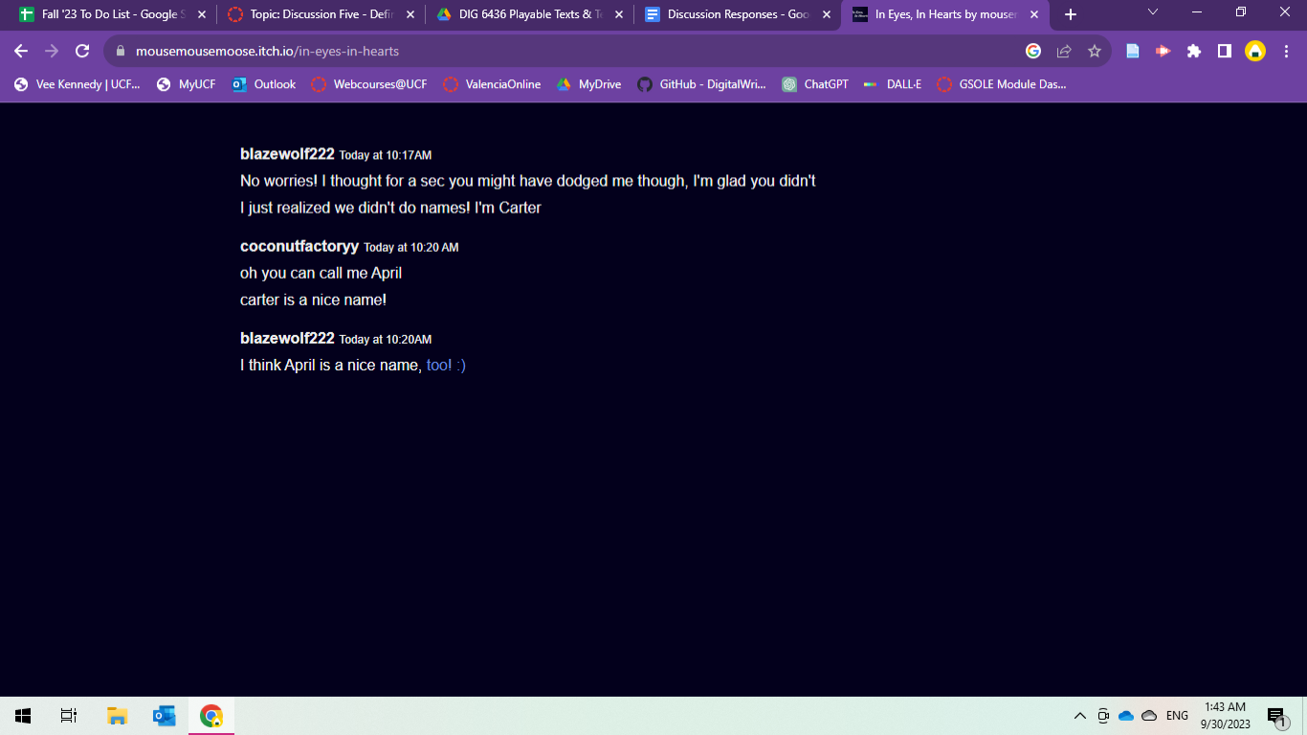
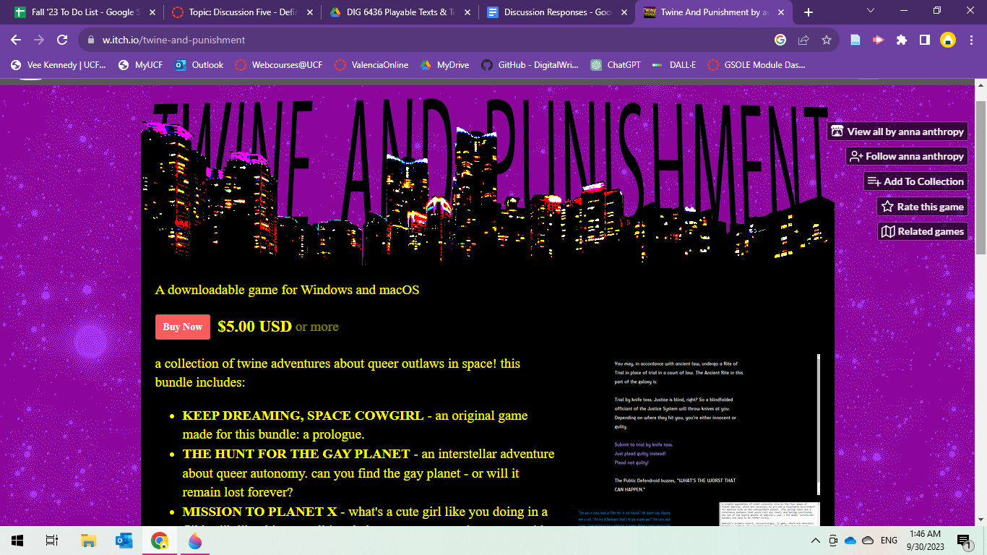
In terms of where these various pieces fit into definitions of electronic literature, I have some thoughts. I ran back to find my own post data from where I talked about Queers in Love a few weeks ago, where I said...
...' Rettberg's definition from Electronic Literature (2019), also quoted here from The Origins of Electronic Literature: An Overview (2021), refers to literature that "would not be possible without the contemporary digital context," (1). In terms of the digital context, again, the itch.io mode of hyperlinked storytelling [In Queers in Love] provides a certain kind of depth of experience that frankly would not be the same in a print-alone media.'
When I wrote that above, I was writing about Queers in Love using not only Twine to hyperlink text pieces, but also the counter. Interestingly, the other projects I've picked up since do not have the counter aspect, and instead rely more on text with hyperlinking and some mild decoration. In Eyes, In Hearts is interesting to me because not only is it a born-digital project making use of hypertext, but part of the storytelling is primarily done through text that's made to look like an online chat room from perhaps the 2010s. It gives MSN Messenger or AIM vibes, and the text-based emojis present in them are ones that I recall using quite prolifically in that era. There's nothing quite flashy like a timer in In Eyes, In Hearts -- it's a piece of interactive fiction, certainly, and queer in that it follows a young transwoman and a young gay man as teenagers looking for role play friends in the furry community who later meet as adults. The creator of In Eyes, In Hearts, has other releases that are much more visual in nature that are not as explicitly queer, so I'm noticing something potentially interesting about hypertext storytelling for queer romance, I suppose. I don't want to make any broad generalizations there. The visual features are something I've observed within three-ish pieces, after all, and certainly I am barely scratching the surface.
I also wanted to go back to the 1992 Coover article that I discussed in my thoughts about Perec's W or the Memory of Childhood, where he describes hypertext by saying “IN hypertext, multivocalism is popular, graphic elements, both drawn and scanned, have been incorporated into the narratives, imaginative font changes have been employed to identify various voices or plot elements, and there has also been a very effective use of formal documents not typically used in fictions -- statistical charts, song lyrics, newspaper articles, film scripts, doodles and photographs, baseball cards and box scores, dictionary entries, rock music album covers, astrological forecasts, board games and medical and police reports...” with regard to how some of these itch.io pieces are decidedly more text-based, still with quite a few affordances than we perhaps see in a print text, but much less than what Coover was perhaps anticipating/describing here in 1992. I mean, I suppose each of these pieces could be said to have 'imaginative font changes' (especially comparing 1992 fonts to 2023 fonts), but it's interesting I suppose that despite being inherently hyperlinked with possibility for space, they do tell mostly linear text-based stories. When I mention linearity here, I'm thinking about how in Queers in Love, regardless of which paths you choose, the story ultimately ends in the end of the world. In In Eyes, In Hearts, you can explore around scenes, but ultimately the characters still end up meeting as adults. So, that's one thing I'm interested in. I do appreciate the irony of these queer stories having perhaps one thing "straight" about them.
In terms of an overall framework for analysis, apart from what I've said above, I've also been thinking back to my queer rhetoric background and particularly K M Rawson's work where he describes the nature of queer archival work in rhetoric and what precisely ends up being included and excluded from archives and what becomes 'canon', so to speak. I was introduced to this piece in Dr. Arellano's Gendered Rhetorics course last fall and specifically, I recall this piece in the context of what is excluded from the feminist rhetorical canon, and how that canon has traditionally been extraordinarily trans exclusive and cissexist. I'm not exactly sure how I presume to do this as of yet, but I think what I'd like to do is argue at looking at some of these queer text-based Twine pieces as contemporary sites of queer and trans rhetorics. This was also inspired in part by the Ruberg reading this week The Mystery of the Missing AIDS Crisis: A Comparative Reading of Caper in the Castro and Murder on Main Street, which takes a very different take on the idea of 'what's missing?' in terms of not what's missing from an archive or a canon but the idea of the entire AIDS epidemic being relatively absent in Video Games during the 80's and 90's when AIDS was a hot topic in other forms of media at the time. In this context, the rhetorical silence of omission is also potentially interesting -- again, part of why I see these games as a particular site of interest that I think is at very least underappreciated by rhetoricians (Boghost and procedural rhetoric aside).

---
Coover, Robert. "The End of Books" (1992). The New York Times.
Hayles, N. Katherine. Electronic Literature : New Horizons for the Literary, University of Notre Dame Press, 2008. ProQuest Ebook Central, http://ebookcentral.proquest.com/lib/ucf/detail.action?docID=3441028
Links to an external site.
Rawson, K. J. “Queering Feminist Rhetorical Canonization.” Feminist Rhetorical Methods and Methodologies (Composition, Literacy, and Culture), University of Pittsburgh Press, 2010, pp. 39–52.
Rosario, G.d. , Meza, N. , & Grimaldi, K. (2021). The Origins of Electronic Literature: An Overview. In J. O’Sullivan (Authors), Electronic Literature as Digital Humanities: Contexts, Forms, & Practices (pp. 9–26). New York,: Bloomsbury Academic. Retrieved August 23, 2023, from http://dx.doi.org/10.5040/9781501363474.ch-00
Links to an external site.
Ruberg, Mo. The Mystery of the Missing AIDS Crisis: A Comparative Reading of Caper in the Castro and Murder on Main Street (2022). American Literature, Volume 94, Number 1, DOI 10.1215/00029831-9696987
WEEK 6
- Provide at least one screenshot and a brief description of your experience with the game to contextualize it for your peers. (1 point)
- How does this work fit in the definitions, genres, and formal conventions we've discussed thus far? Make sure to cite at least one definition that is particularly relevant. (1 point)
- What parallels can you draw between this piece and works categorized as either electronic literature and games? Consider drawing comparisons to the work you are studying, or to one we've explored earlier this semester. (1 point)
Naturally, I picked a queer one as a sort of companion piece for thinking of Queers in Love, specifically, Butterfly Soup by Brianna Lei on itch. The game description page refers to this piece as “a visual novel about gay asian girls playing baseball and falling in love,” and claims to be about 3-4 hours long, so I was quite excited to look at this piece in conjunction with Queers in Love because technically there’s a bit of overlap here in that they’re both queer itch.io pieces with romantic stories about queer femmes, but apart from that, they diverge significantly. Butterfly Soup describes itself as being a visual novel and fits that bill quite readily. It was built was RenPy (as in, yes, Python, for anyone else in Humanist Data Analysis). RenPy is apparently a “visual novel engine…[and is] open source and free for commercial use,” according to their site. Doki Doki Literature Club was made with this as well, per their site.
Butterfly Soup reports to include 3-4 hours of gameplay, which is very impressive for a name-your-price indie game on itch, at least to me! I’m a little bit more than a half-hour in at this point and to me it feels very much like a game. This piece has visuals, a user interface that reminds one of a dating sim, background music and other sound bytes, loading screens, and click through options with multiple paths that seem to have a strong influence on the outcome of events around you in the game. It’s also been translated into several languages and has a sequel now. So, where do we fit Butterfly Soup in terms of formal conventions and such? This becomes interesting for me because it very much refers to itself as a visual novel, not a game, in the description on itch, but if you dig into the Press Kit, the creator refers to it as a game there. Per the press kit, this piece was awarded IGN Japan’s best Indie Game of 2019, was an IGF Excellence in Narrative finalist in 2018, awarded PC Gamer’s Best Visual Novel in 2017, and was included in the Rainbow Arcade exhibit at the Schwules Museum in Berlin from 2018-2019 (which, if the name doesn’t give it away, is/was an art exhibit on the history of queer games). Clearly across the board, there’s a bit of malleability about what category users and award judges feel this piece belongs in. It seems to have reached a certain amount of success all things given – people like this thing – but what is it? To me, I felt more like I was playing through a version of Alice Oseman’s Heartstopper than reading a visual novel at times.
To me, I felt more like I was playing through a version of Alice Oseman’s Heartstopper than reading a visual novel at times. This in no way a critique -- do not even get me started on the soul-nourishing joy that both Butterfly Soup and Heartstopper bring to someone like me who was raised in the era when queer characters were finally permitted to exist in YA books, but they had to be really, really sad and angsty. Long ago in a different part of my life, I attended the 2017 Writer's Digest Conference in Manhattan to pitch a Queer YA piece and happened to attend a talk where Rainbow Rowell and another author (whose name is conveniently slipping my mind) lament about this very idea -- for the longest time in mainstream commercial YA publishing, there was this trend where queer teenagers could exist, but they had to be extremely tormented about it. That's more an aside about narrative than it is about the ludability of this piece so I'll get off my soap box now, but I see another interesting point there with regard to Queers in Love at the End of the World. When I first picked that piece off the syllabus, I remember seeing the title and thinking to myself 'God, I hope this isn't another dead lesbian story,' and funnily enough, it actually was -- but not in the way I expected prior to engaging with it. I have much more to go into Butterfly Soup, but I anticipate that this piece does not end with character death (given that it's not listed in the trigger warning tags) (given that it's not listed in the trigger warning tags -- which, getting into Ensslin's verbiage, speaks again to the "gameified" aspect of whatever this piece is -- novels don't usually come with TWs, even if we'd like them to).
So, back to definitions, literature, and ludability -- what is Butterfly Soup? I'll bring in definitions from Ensslin shortly, but I wanted first to share a different definition I came across this week, specifically from the class slides from Humanist Data Analysis. I haven't actually read this book entitled Rules of Play, but I think this definition is interesting to think of with regard to both Butterfly Soup and Queers in Love:

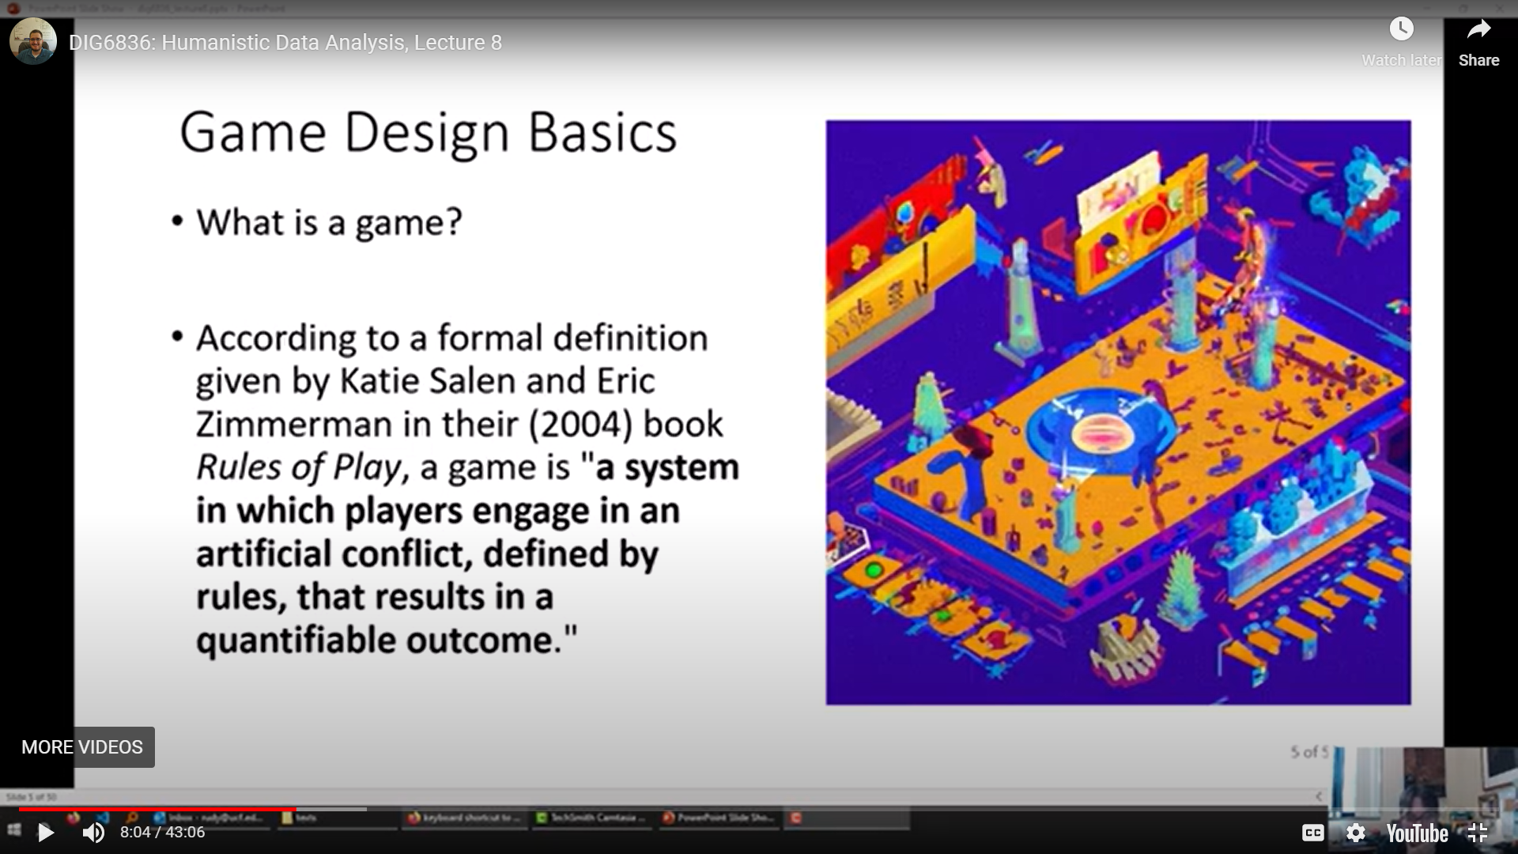
https://www.renpy.org/

This definition (which, according to McDaniel's lecture on it, is distilled from about a dozen other definitions) refers to some key points that I'd like to touch on - artificial conflict, rules, and a quantifiable outcome (which McDaniel goes on to describe as a clear 'win' or 'lose' outcome in terms of how we're expected to code our Spooky Escape Rooms over the next few weeks, although I don't know if that quantifiable outcome necessarily means a 'win' or 'lose' for Salen & Zimmerman). I think it's fair to say that both Queers in Love and Butterfly Soup have conflict and rules of sorts, but an outcome...? The outcome in both of these pieces seem somewhat linear and unavoidable. I haven't gotten to the end of Butterfly Soup so perhaps I'll be surprised, but a sequel came out in 2022, so my anticipation is that Butterfly Soup will end on some sort of end of a given linear plot thread and that regardless of the conflict options chosen throughout the game, the ending will be at least somewhat happy in nature. Queers in Love, of course, features a much less joyful linear ending -- the literal apocalypse. Do either of these pieces have a clear, quantifiable outcome...? Well, yes, but it doesn't seem like the user can avoid that outcome in any way. No matter what paths you choose in Queers in Love, you have the same outcome. For Butterfly Soup, I anticipate that this will be perhaps the same, albeit with a much happier 'ending'.
Going further into our definitions, in this week's chapter of Ensslin, she describes at one point a certain kind of ludic-literary spectrum with a game called Clues landing smack-dab in the middle of those two definitions. Clues is quite literary in nature, but it also contains ludic elements -- "readers are made to collect clues for credits, they can win or lose the game, they can save the game to return to where they left off at any given time, and they have to meet the challenge of developing reading strategies that will help them avoid the risk of accruing red herrings rather than real clues." -- which makes it sound an awful lot like Butterfly Soup. I also want to draw from Rettburg this week, who provides us with a description of hypertext that states: "Some essential components of hypertext—breaking the narrative line; structuring stories into small segments, episodes, or nodes; enabling readers to interact with or arrange the presentation of narratives in various ways; weighing the user interface, graphic presentation, and navigational apparatus as poetic elements of the work—have carried through into a variety of other digital narrative forms. No story is boundless. The story must eventually cease, and the author—pathetic mortal—must eventually die," which, seems to point quite readily to games or at very least, something in the middle of what Ensslin's describing as this ludic-literary spectrum.
Earlier on in Ensslin, she also makes this claim about games distinctly not being digital literature because they are not literary: "digital literature excludes at least two mainstream forms of digital media that we might otherwise associate with the term: e-books or any other paper-under-glass forms of digital writing that can be printed without losing their specific aesthetic appeal and distinctive interactive qualities; and videogames that we cannot read in the sense of close-read and close-play for their artistic verbal and ludological forms and contents. Clearly, most videogames contain written and spoken language, most typically in character dialogues, backstory descriptions, instructions, interface items, and paratextual materials (box blurbs, websites, commercials, and so forth). However, the vast majority of them do not use literary language (spoken or written) in the sense of verbal art as previously explained, and this book seeks to shed light on precisely the small but growing group of games that do," which, I struggle with a bit, as I am reminded of my Creative Writing MA where 'literary fiction' was this kind of academic field that distinctly excluded anything commercial or any kind of genre fiction that might be enjoyed by a wider audience, and I'm wondering that's what Ensslin's getting at here.

(Bell et al. 2010, n.p.). In other words, digital literature excludes at least two mainstream forms of digital media that we might otherwise associate with the term: e-books or any other paper-under-glass forms of digital writing that can be printed without losing their specific aesthetic appeal and distinctive interactive qualities; and videogames that we cannot read in the sense of close-read and close-play for their artistic verbal and ludological forms and contents. Clearly, most videogames contain written and spoken language, most typically in character dialogues, backstory descriptions, instructions, interface items, and paratextual materials (box blurbs, websites, commercials, and so forth). However, the vast majority of them do not use literary language (spoken or written) in the sense of verbal art as previously explained, and this book seeks to shed light on precisely the small but growing group of games that do.
Ensslin, Astrid. Literary Gaming, MIT Press, 2014. ProQuest Ebook Central, http://ebookcentral.proquest.com/lib/ucf/detail.action?docID=3339803.
tral, http://ebookcentral.proquest.com/lib/ucf/detail.action?docID=3339803.
Created from ucf on 2023-10-05 10:30:40.
Nevertheless, Clues displays a range of formal ludic mechanics that situate it considerably closer to the ludic end of the L-L spectrum than the other three hypertexts: readers are made to collect clues for credits, they can win or lose the game, they can save the game to return to where they left off at any given time, and they have to meet the challenge of developing reading strategies that will help them avoid the risk of accruing red herrings rather than real clues.
Ensslin, Astrid. Literary Gaming, MIT Press, 2014. ProQuest Ebook Central, http://ebookcentral.proquest.com/lib/ucf/detail.action?docID=3339803.
Created from ucf on 2023-10-05 10:41:07.

Rettburg -
Some essential components of

hypertext
—
breaking the narrative line; structuring stories into small segments,

episodes, or nodes; enabling readers to interact with or arrange the

presentation of narrativ
es in various ways; weighing the user interface,

graphic presentation, and navigational apparatus as poetic elements of the

work
—
have carried through into a variety of other digital narrative forms.

No story is boundless. The story must eventually cease, and the author
—

pathetic mort
al
—
must eventually die. In some ways it does seem as if the

American hypertext novel is a kind of ghost town
—
a narrative genre that was

quickly discovered, developed, evolved, and then abandoned in pursuit of new

territories before it ever reached its full
potential. Of course, while stories end

and writers expire, once invented, literary forms don’t ever really perish. They

merely go into hibernation and, in dormancy, await their rediscovery and

reinvention. And so it may be with the hypertext novel.
We have seen how

many of the theoretical underpinnings, structural elements, and narrative

techniques of hypertext have migrated into other forms of digital narrative.

This is not however to say that the hypertext novel has simply been raided for

spare par
ts. La Farge’s experiment, if not entirely successful, is evidence that

the form is not completely moribund.
It is entirely likely that authors will

return to the hypertext, embrace its comparative computational simplicity,

which while driven towards exces
s is also in its own way austere, and will

develop its future even as they learn from its past. Hypertext is dead. Long

live hypertext.

https://electronicbookreview.com/essay/why-twining/
However, Twine is a tool that particularly resonates for those with something personal to say, and Twine’s importance and visibility on the web have often risen correspondingly with conflict. At a time when our technology is increasingly complex, sealed in tiny boxes and inscrutable to most of its users, Twine is transparent and open. At a time when our software is produced by large teams, with most of the production members hyperfocused on a project part, Twine allows a single person to develop an interactive experience holistically, without relying on any external specialist’s knowledge. Twine is a tool for resisting the dominant interactive storytelling of our times and, as such, tends to be a tool for chronicling resistance and struggle. - salter & Moulthrop

At the same time, as Catherine

D
’
Ignazio and Lauren F. Klein explain in their book
Data Feminism

(2020), there is also power in allowing information to remain missing
—

for example, by permitting knowledge about the lives of marginalized

groups to go unsurfaced and unrecorded by the government and other

surveilling bodies. D
’
Ignazio and Klein
’
s work suggests that being

missing may be its own site of meaning. To be meaningful, a piece of

information or an element of history need not be explicitly present. It

may take on new, more radical forms of meaning precisely by being

absent. This may also be true for HIV/AIDS in video games.
- Ruberg AIDS and games on Data Feminism

Week 7: Antilucidity
- Provide at least one screenshot and a brief description of your experience with the game to contextualize it for your peers. (1 point)
- How does this work resist play, break, or expand the definitions, genres, and formal conventions we've discussed thus far? Make sure to cite at least one definition that is particularly relevant. (1 point)
- What parallels can you draw between this piece and works categorized as either electronic literature and games? Consider drawing comparisons to the work you are studying, or to one we've explored earlier this semester. (1 point)
As with our last discussion, plan on posting three times: once with a discussion of the work you've selected, and twice to reply to peers (2 points).

https://www.presenttensejournal.org/editorial/vol-6-3-special-issue-on-the-rhetoric-of-platforms/

